Q1 Differential Histogram output: ( I think you should (better to) open Colab and hover over graphs to check the output of Histograms and compare them to original)

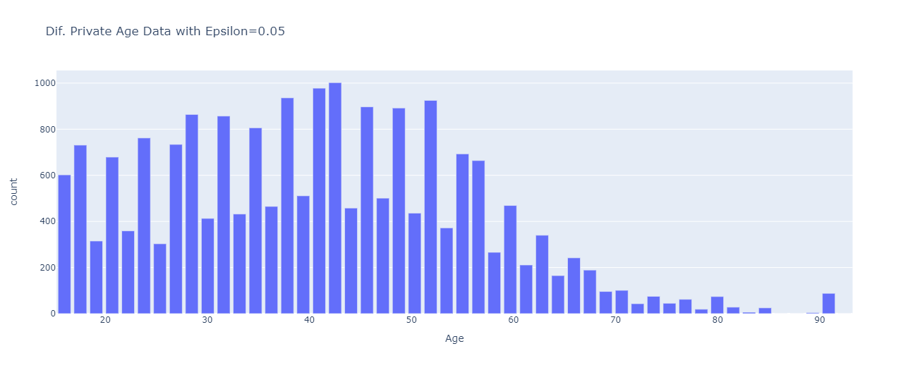

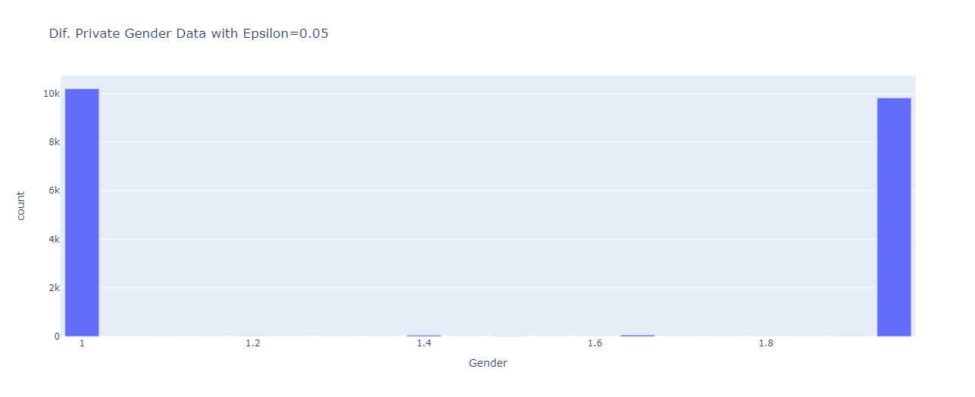

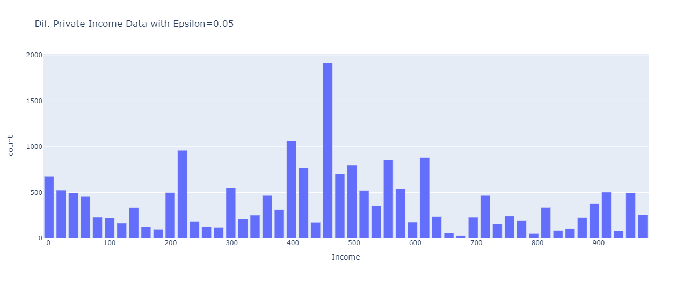

Q2) part B ( Please view the Colab for more information on Q2):

On average, the MSE will decrease either if N is increased or bins range decreased.